**ITEC301 DELIVERABLE 2**

**DOCUMENTATION AND CODING**

|  |  |
| --- | --- |
| **Student Name:** | **ANDREW HART** |
| **Student Number:** | **W9HDSQ182** |
| **Project Title:** | **WESTERN CAPE TUTORS** |
| **Submission Date:** | **2020/08/11** |

Contents

Introduction 3

Prototyping 3

Prototype 1. 5

Laptop Screen Size 5

Phone Screen Size 9

Prototype 2. 13

Laptop Screen Size 13

Phone Screen Size 15

Client response to the Prototypes 19

Designing 20

Class Responsibility Collaborator (CRC) cards 20

Enhanced Entity Relationship Diagram (EERD) 20

Context Diagram 20

Data Flow Diagram (DFD) 20

Use Case Diagram 20

Database Design 20

Coding 20

Screen shots 20

Sample PHP Code 20

Sample HTML Code 20

Sample JavaScript Code 20

Sample CSS Code 20

Sample MySQL Table Screen shots 20

Conclusion 20

Sign-off 20

# Introduction

Western Cape Tutors is an organization that allows tutors from around the Western Cape to share their profile information to anyone seeking tutor assistance. This website allows a user to browse through a wide variety of tutors within the Western Cape. This program allows a user to filter search results based on location, gender, subjects, and many more, which will narrow down the available tutors best suited for your child. If a user wishes to create an advertisement, he/she will be required to register first, whereafter they will be prompted to log in. After the user has logged in to the server, he/she will then be able to post all of their details regarding their tutor position to the database. This advertisement will include details such as experience, transport status, age ranges, and many more.

# Prototyping

## Prototype 1.

### Laptop Screen Size

|  |
| --- |
|  |
|  |
|  |
|  |

### Phone Screen Size

|  |
| --- |
|  |
|  |
|  |
|  |

## Prototype 2.

### Laptop Screen Size

|  |
| --- |
|  |
|  |

### Phone Screen Size

|  |
| --- |
|  |
|  |
|  |
|  |

# Client response to the Prototypes

To whom it may concern,

This morning Andrew Hart presented me with two prototypes for the Western Cape Tutor application.

I was impressed by the styling of both of them, but in the end have opted for Option 1.

I particularly enjoyed the fresh styling and effects, and especially its responsiveness (mobile-friendly) when displayed on a laptop, tablet or mobile phone.

For the next phase of development, I would like to see the following functionality included:

* Any unauthenticated person must be able to Search the site
* However, a person must be authenticated (i.e. registered and logged in) in order to place a posting
* The website must have the option for changing the user’s password
* Additionally, the concept of an administrator needing to approve or reject new postings, in order to combat the inevitable flood of unwanted spam and junk
* We discussed having a "likes" indicator, although a person would probably then need to have logged-in in order to persist, so we decided against that.
* I also requested the change of background colors to something easier on the eye, to increase the look of professionalism
* We also made minor styling adjustments to improve the overall look and feel of the website

I am very optimistic about the future of this development, and look forward to seeing progress on a regular basis.

Kind Regards

B.W.Hart

0823320218

# Designing

## Class Responsibility Collaborator (CRC) cards

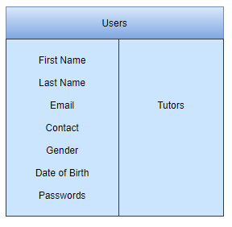

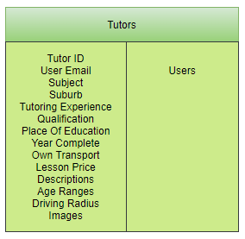

## Enhanced Entity Relationship Diagram (EERD)

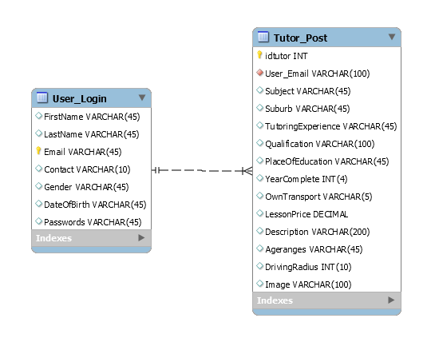

## Context Diagram

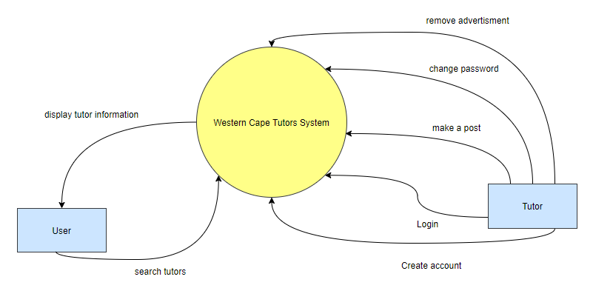

## Data Flow Diagram (DFD)

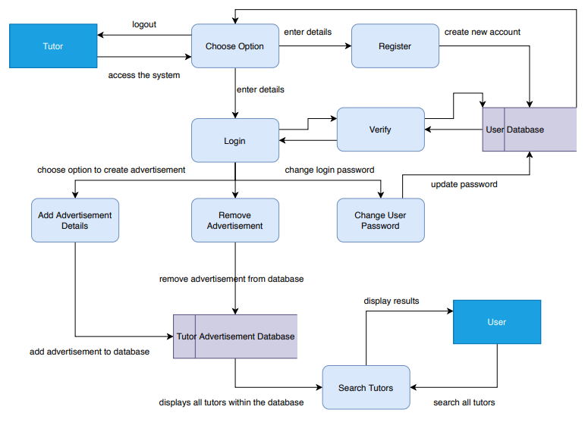

## 

## Use Case Diagram

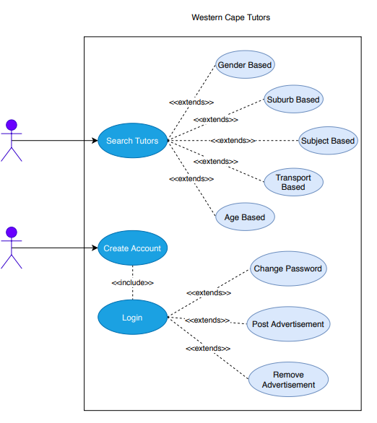

## Database Design

# Coding

Provide the screen shots and code samples of the final website. You do not have to print every code on your website. Use the following as guideline and explain what each sample code provided is used for on the website:

## Screen shots

## Sample PHP Code

## Sample HTML Code

## Sample JavaScript Code

## Sample CSS Code

## Sample MySQL Table Screen shots

# Conclusion

# Sign-off

|  |  |  |  |
| --- | --- | --- | --- |
|  |  |  |  |
| [Name], Project Client  Date: _____________________ |  |  | [Name], Project Manager  Date: _____________________ |